****Year 7 Physics

Name __________________________

Task 5: Levers Investigation

**Investigating Levers**

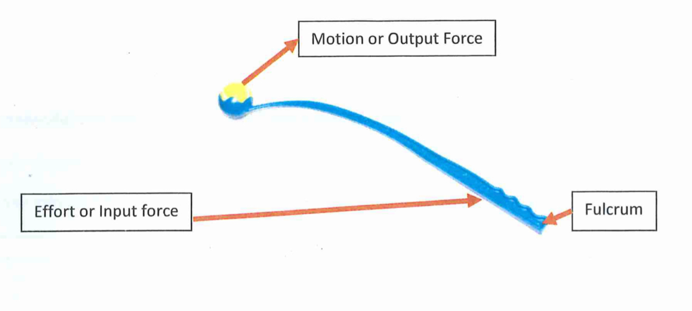The dog ball thrower is a plastic lever, similar to the miro as it lengthens the thrower’s arm. It is a simple machine that gives the thrower a mechanical advantage and is an example of a **third class lever.** The fulcrum is located at the handle, where the thrower grips. Similarly, it too allows you to throw the tennis ball further distances with increased velocity, acceleration and force.

You will be working in a group of four to carry out an experiment with the following aim:

***To test if a tennis ball thrown using a dog ball thrower will travel a greater distance than one thrown without a dog ball thrower.***

Although you are working in a group, each person needs to complete this worksheet and bring a copy of it to class to sit a validation test.

**Planning**

1. Complete the table to show the variables of this experiment

|  |  |
| --- | --- |
| Independent |  |
| Dependent |  |
| Control |  |
|  |

1. What is your hypothesis for this experiment?

______________________________________________________________________________________________________________________________________________________________________________

*Materials*

* Pen
* Tennis ball
* Dog ball thrower
* Cone or marker
* 100m tape
* Calculator

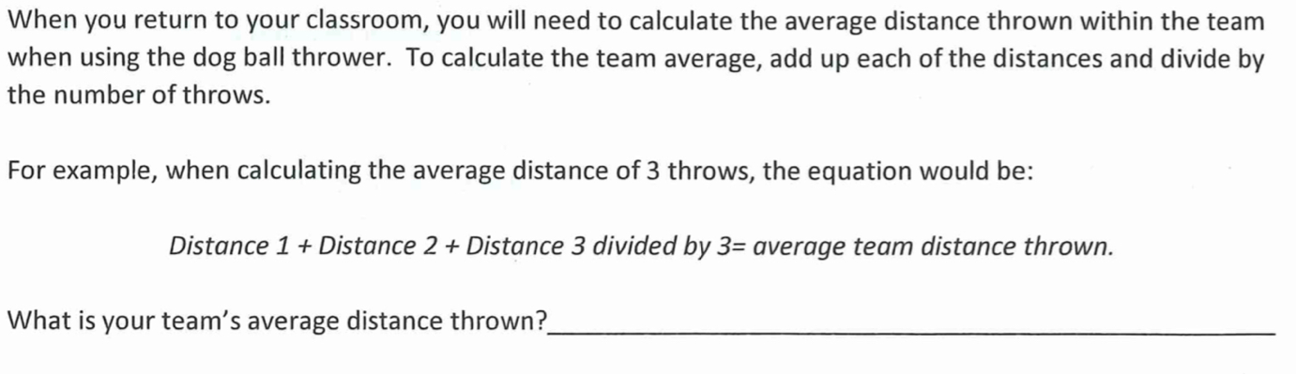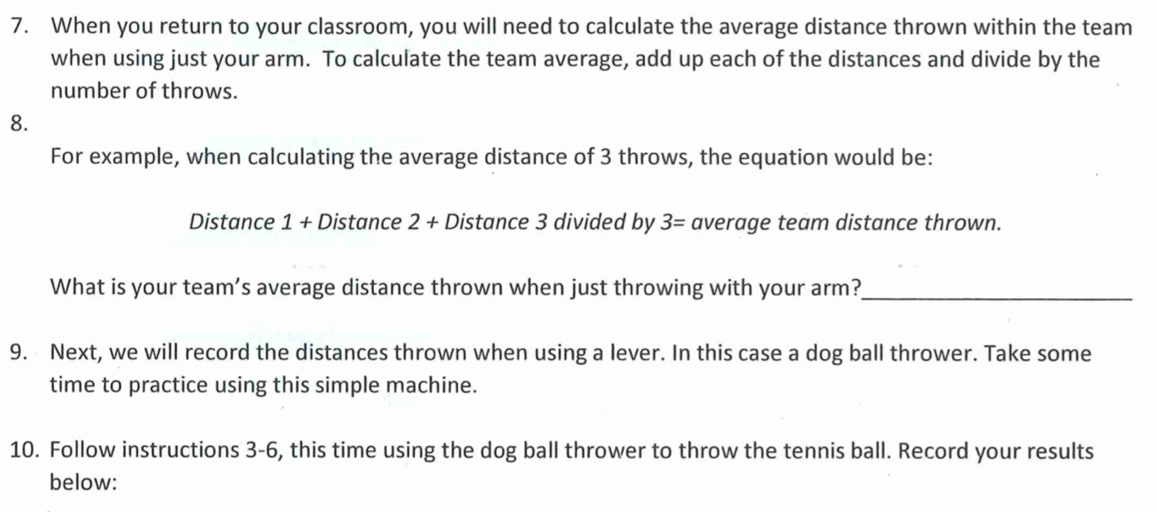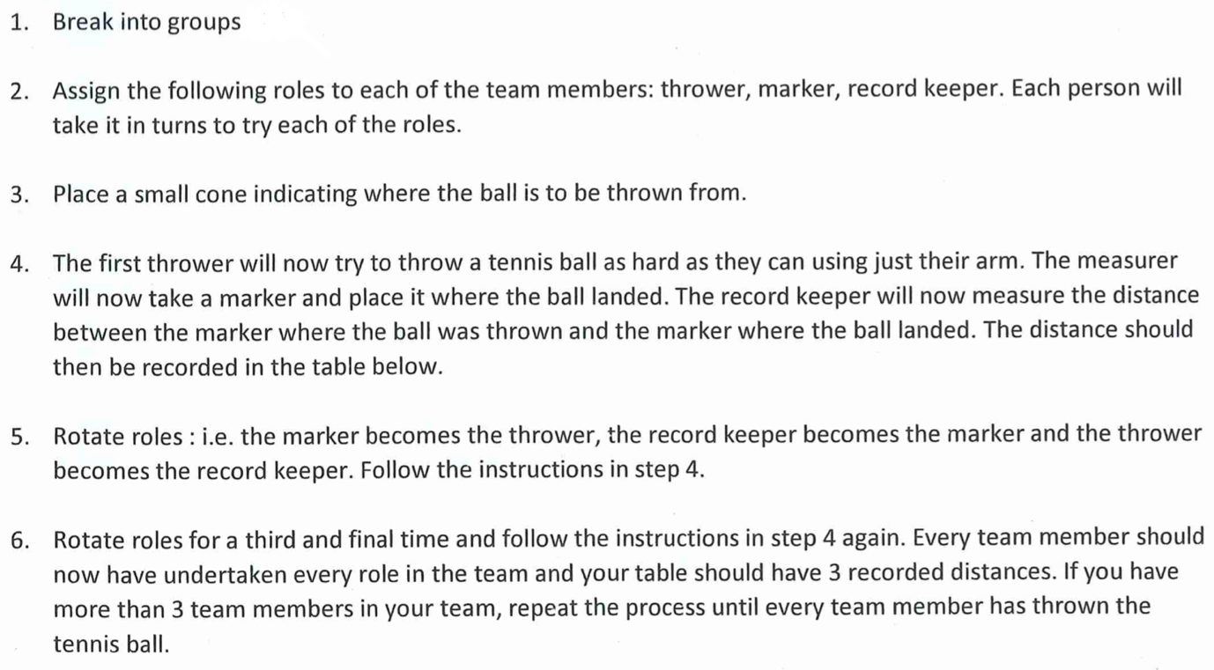*Method*

1. What are two safety considerations that should be taken when conducting this experiment?

____________________________________________________________________________________________________________________________________________________________________________________________________________________________________________________________________________________________________________________________________________________________

1. Create a table below to record your measurements when you carry out the experiment. Remember each person in your group will throw without the dog ball thrower and with the dog ball thrower. You will also need space to write your average distance.
2. Complete the experiment and fill in your table.